Critical Path Method

Introduction

If you have been into project management, I'm sure you have already heard the term 'critical path method.'

If you are new to the subject, it is best to start with understanding the 'critical path' and then move on to the 'critical path method.'

Critical path is the sequential activities from start to the end of a project. Although many projects have only one critical path, some projects may have more than one critical paths depending on the flow logic used in the project.

If there is a delay in any of the activities under the critical path, there will be a delay of the project deliverables.

Most of the times, if such delay is occurred, project acceleration or re-sequencing is done in order to achieve the deadlines.

Critical path method is based on mathematical calculations and it is used for scheduling project activities. This method was first introduced in 1950s as a joint venture between Remington Rand Corporation and DuPont Corporation.

The initial critical path method was used for managing plant maintenance projects. Although the original method was developed for construction work, this method can be used for any project where there are interdependent activities.

In the critical path method, the critical activities of a program or a project are identified. These are the activities that have a direct impact on the completion date of the project.

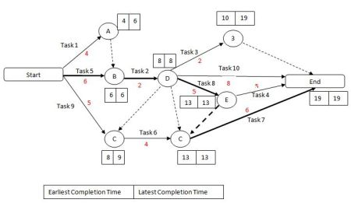

Key Steps in Critical Path Method

Let's have a look at how critical path method is used in practice. The process of using critical path method in project planning phase has six steps.

Step 1: Activity specification

You can use the Work Breakdown Structure (WBS) to identify the activities involved in the project. This is the main input for the critical path method.

In activity specification, only the higher-level activities are selected for critical path method.

When detailed activities are used, the critical path method may become too complex to manage and maintain.

Step 2: Activity sequence establishment

In this step, the correct activity sequence is established. For that, you need to ask three questions for each task of your list.

* Which tasks should take place before this task happens.
* Which tasks should be completed at the same time as this task.
* Which tasks should happen immediately after this task.

Step 3: Network diagram

Once the activity sequence is correctly identified, the network diagram can be drawn (refer to the sample diagram above).

Although the early diagrams were drawn on paper, there are a number of computer softwares, such as Primavera, for this purpose nowadays.

Step 4: Estimates for each activity

This could be a direct input from the WBS based estimation sheet. Most of the companies use 3-point estimation method or COCOMO based (function points based) estimation methods for tasks estimation.

You can use such estimation information for this step of the process.

Step 5: Identification of the critical path

For this, you need to determine four parameters of each activity of the network.

* Earliest start time (ES) - The earliest time an activity can start once the previous dependent activities are over.
* Earliest finish time (EF) - ES + activity duration.
* Latest finish time (LF) - The latest time an activity can finish without delaying the project.
* Latest start time (LS) - LF - activity duration.

The float time for an activity is the time between the earliest (ES) and the latest (LS) start time or between the earliest (EF) and latest (LF) finish times.

During the float time, an activity can be delayed without delaying the project finish date.

The critical path is the longest path of the network diagram. The activities in the critical path have an effect on the deadline of the project. If an activity of this path is delayed, the project will be delayed.

In case if the project management needs to accelerate the project, the times for critical path activities should be reduced.

Step 6: Critical path diagram to show project progresses

Critical path diagram is a live artefact. Therefore, this diagram should be updated with actual values once the task is completed.

This gives more realistic figure for the deadline and the project management can know whether they are on track regarding the deliverables.

Advantages of Critical Path Method

Following are advantages of critical path methods:

* Offers a visual representation of the project activities.
* Presents the time to complete the tasks and the overall project.
* Tracking of critical activities.

Conclusion

Critical path identification is required for any project-planning phase. This gives the project management the correct completion date of the overall project and the flexibility to float activities.

A critical path diagram should be constantly updated with actual information when the project progresses in order to refine the activity length/project duration predictions.

Gantt Chart Tool

Introduction

Gantt chart is a type of a bar chart that is used for illustrating project schedules. Gantt charts can be used in any projects that involve effort, resources, milestones and deliveries.

At present, Gantt charts have become the popular choice of project managers in every field.

Gantt charts allow project managers to track the progress of the entire project. Through Gantt charts, the project manager can keep a track of the individual tasks as well as of the overall project progression.

In addition to tracking the progression of the tasks, Gantt charts can also be used for tracking the utilization of the resources in the project. These resources can be human resources as well as materials used.

Gantt chart was invented by a mechanical engineer named Henry Gantt in 1910. Since the invention, Gantt chart has come a long way. By today, it takes different forms from simple paper based charts to sophisticated software packages.

The Use

As we have already discussed, Gantt charts are used for project management purposes. In order to use Gantt charts in a project, there are a few initial requirements fulfilled by the project.

First of all, the project should have a sufficiently detailed Work Breakdown Structure (WBS).

Secondly, the project should have identified its milestones and deliveries.

In some instances, project managers try to define the work break down structure while creating Gantt chart. This is one of the frequently practised errors in using Gantt charts. Gantt charts are not designed to assist WBS process; rather Gantt charts are for task progress tracking.

Gantt charts can be successfully used in projects of any scale. When using Gantt charts for large projects, there can be an increased complexity when tracking the tasks.

This problem of complexity can be successfully overcome by using computer software packages designed for offering Gantt chart functionalities.

Tools Available

There are dozens of Gantt chart tools that can be used for successful project tracking. These tools usually vary by the feature offered.

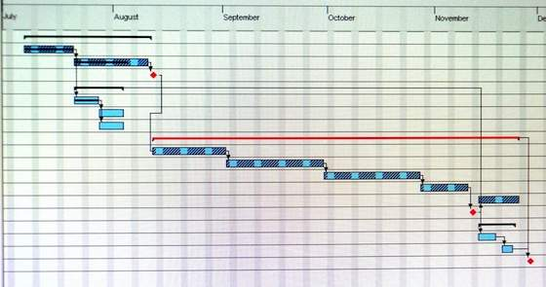

The simplest kind of Gantt chart can be created using a software tool such as Microsoft Excel. For that matter, any spreadsheet tool can be used to design a Gantt chart template.

If the project is small scale and does not involve many parallel tasks, a spreadsheet based Gantt chart can be the most effective type.

Microsoft Project is one of the key Gantt chart tools used today. Especially for software development projects, MS Project based Gantt charts are essential to track the hundreds of parallel tasks involved in the software development life cycle.

There are many other Gantt chart tools available for free and for price. The features offered by these tools range from the same features offered by Excel based Gantt charts to MS Project Gantt charts. These tools come with different price tags and feature levels, so one can select the suitable Gantt chart tool for the purpose in hand.

Creating Your Own

Sometimes, one may decide to create their own Gantt chart tool without buying an existing one. If this is the case, first of all, one should search the Internet for free Gantt chart templates.

This way, one may actually find the exact Gantt chart template (probably in Excel) required for the purpose. In case, if no match is found, then it is sensible to create one's own.

Excel is the most popular tool for creating custom Gantt charts. Of course, one can create a Gantt chart from scratch in Excel, but it is always advisable to use a Project Management add-on in Excel to create Gantt charts.

These project management add-ons are published by Microsoft and other third-party companies.

Advantages & Disadvantages

The ability to grasp the overall status of a project and its tasks at once is the key advantage in using a Gantt chart tool. Therefore, upper management or the sponsors of the project can make informed decisions just by looking at the Gantt chart tool.

The software-based Gantt charts are able to show the task dependencies in a project schedule. This helps to identify and maintain the critical path of a project schedule.

Gantt chart tools can be used as the single entity for managing small projects. For small projects, no other documentation may be required; but for large projects, the Gantt chart tool should be supported by other means of documentation.

For large projects, the information displayed in Gantt charts may not be sufficient for decision making.

Although Gantt charts accurately represent the cost, time and scope aspects of a project, it does not elaborate on the project size or size of the work elements. Therefore, the magnitude of constraints and issues can be easily misunderstood.

Conclusion

Gantt chart tools make project manager's life easy. Therefore, Gantt chart tools are important for successful project execution.

Identifying the level of detail required in the project schedule is the key when selecting a suitable Gantt chart tool for the project.

One should not overly complicate the project schedules by using Gantt charts to manage the simplest tasks.

PERT Estimation Technique

Introduction

Before any activity begins related to the work of a project, every project requires an advanced, accurate time estimate. Without an accurate estimate, no project can be completed within the budget and the target completion date.

Developing an estimate is a complex task. If the project is large and has many stakeholders, things can be more complex.

Therefore, there have been many initiatives to come up with different techniques for estimation phase of the project in order to make the estimation more accurate.

PERT (Program Evaluation and Review Technique) is one of the successful and proven methods among the many other techniques, such as, CPM, Function Point Counting, Top-Down Estimating, WAVE, etc.

PERT was initially created by the US Navy in the late 1950s. The pilot project was for developing Ballistic Missiles and there have been thousands of contractors involved.

After PERT methodology was employed for this project, it actually ended two years ahead of its initial schedule.

The PERT Basics

At the core, PERT is all about management probabilities. Therefore, PERT involves in many simple statistical methods as well.

Sometimes, people categorize and put PERT and CPM together. Although CPM (Critical Path Method) shares some characteristics with PERT, PERT has a different focus.

Same as most of other estimation techniques, PERT also breaks down the tasks into detailed activities.

Then, a Gantt chart will be prepared illustrating the interdependencies among the activities. Then, a *network* of activities and their interdependencies are drawn in an illustrative manner.

In this map, a *node* represents each event. The activities are represented as arrows and they are drawn from one event to another, based on the sequence.

Next, the Earliest Time (TE) and the Latest Time (TL) are figured for each activity and identify the slack time for each activity.

When it comes to deriving the estimates, the PERT model takes a statistical route to do that. We will cover more on this in the next two sections.

Following is an example PERT chart:

The Three Chances

There are three estimation times involved in PERT; Optimistic Time Estimate (TOPT), Most Likely Time Estimate (TLIKELY), and Pessimistic Time Estimate (TPESS).

In PERT, these three estimate times are derived for each activity. This way, a range of time is given for each activity with the most probable value, TLIKELY.

Following are further details on each estimate:

1. TOPT

This is the fastest time an activity can be completed. For this, the assumption is made that all the necessary resources are available and all predecessor activities are completed as planned.

2. TLIKELY

Most of the times, project managers are asked only to submit one estimate. In that case, this is the estimate that goes to the upper management.

3. TPESS

This is the maximum time required to complete an activity. In this case, it is assumed that many things go wrong related to the activity. A lot of rework and resource unavailability are assumed when this estimation is derived.

The PERT Mathematics

BETA probability distribution is what works behind PERT. The expected completion time (E) is calculated as below:

E = (TOPT + 4 x TLIEKLY + TPESS) / 6

At the same time, the possible variance (V) of the estimate is calculated as below:

V = (TPESS - TOPT)^2 / 6^2

Now, following is the process we follow with the two values:

* For every activity in the critical path, E and V are calculated.
* Then, the total of all Es are taken. This is the overall expected completion time for the project.
* Now, the corresponding V is added to each activity of the critical path. This is the variance for the entire project. This is done only for the activities in the critical path as only the critical path activities can accelerate or delay the project duration.
* Then, standard deviation of the project is calculated. This equals to the square root of the variance (V).
* Now, the normal probability distribution is used for calculating the project completion time with the desired probability.

Conclusion

The best thing about PERT is its ability to integrate the uncertainty in project times estimations into its methodology.

It also makes use of many assumption that can accelerate or delay the project progress. Using PERT, project managers can have an idea of the possible time variation for the deliveries and offer delivery dates to the client in a safer manner.

Explaining the Precedence Diagram Method (PDM) in Project Management

**PDM Basics**

PDM is a visual representation technique that depicts the activities involved in a project. Precedence Diagrams are also known as Project Network Diagrams. In this article, both terms are used interchangeably. PDM helps you to:

* **Communicate**: The visual representation makes it easier for you to communicate the flow of project execution or the project activity flow.
* **Identify missing activities**: When an activity is not identified, it’ll never be done. By visually representing the activities, there is a greater chance for your team to identify missing activities.
* **Identify dependencies**: Each activity is dependent on some other activity. When a dependency is not identified, the project will be delayed until such a time that identification occurs. For example, if there is a critical component that is being produced by a third-party vendor, the final product is dependent on the vendor. So, even if you complete all other activities, the project will not be complete until the vendor supplies the critical component.
* **Identify critical activities**: Certain activities have a greater impact on project schedule than others. By using PDMs, you can determine the activities critical to the project schedule. This is known as the [Critical Path Method (CPM)](https://www.brighthub.com/office/project-management/articles/49584.aspx).
* **Create a project schedule**: The final goal of PDM is to create a practical and robust project schedule.

**PMP Exam Tip**: There are two visualization techniques, PDM and Arrow Diagramming Method (ADM). Of the two, PDM is used most often.

Now, let’s give dependencies a more in-depth look.

**Types of Dependencies**

There are four types of dependencies that you need to be aware of before creating a Precedence Diagram.

* **Finish-Start**: In this dependency, an activity cannot start before a previous activity has ended. For example, you cannot cook a stew before gathering all the ingredients. Therefore, the activity “Gather Ingredients" needs to finish, before the activity “Cook Stew" can begin. **This is the most commonly used dependency.**
* **Start-Start**: In this dependency, there is a defined relationship between the start of activities.
* **Finish-Finish**: In this dependency, there is a defined relationship between the end dates of activities.
* **Start-Finish**: In this dependency, there is a defined relationship between the start of one activity and the end date of a successor activity. This dependency is rarely used.

**Precedence Diagram Notation**

The image displays a simple Precedence Diagram.

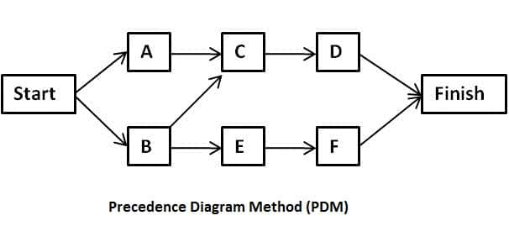

You’ll notice that the Precedence Diagram has the following features:

* **Events:** The Start and End oval shapes signify events. An event is a point in time having no duration, which is also known as a milestone. A Precedence Diagram will always have a Start and an End event.
* **Activity**: There are four activities (Activity 1, 2, 3, and 4), each activity is represented by a node.
* **Dependencies**: Each node (Activities and Events) is connected by using uni-directional arrows. This signifies the relationship between activities. The relationship between activities can either be predecessor or successor. For example in the image, Activity 1 has no dependency, Activities 2 and 3 are dependent on Activity 1, while Activity 4 is dependent on Activities 2 and 3.

**Note**: Since the activities are represented by the node, Precedence Diagrams are also called “activity-on-the-node" diagrams.

A Network Diagram will **always** have the Start and End events. They may also have other events called milestones. For example, kill-points are milestones. In a Network Diagram, **the start of an activity must be linked to the end of another activity**.

How to Create a Precedence Diagram or a Project Network Diagram

**Introduction to a Precedence Diagram or a Project Network Diagram**

In this article, we’ll illustrate how to construct a [Precedence Diagram](https://www.brighthubpm.com/project-planning/49580-overview-of-the-precedence-diagram-method-pdm/) (Project Network Diagram). The steps are:

1. Specify predecessors and successors, given a list of project activities.
2. Arrange the project activities in order of execution.

**Specify Predecessors and Successors Given a List of Project Activities**

This is the first step to creating a Precedence Diagram (Project Network Diagram). In this step, the project activity dependencies are identified. The Precedence Diagram (Project Network Diagram) needs to clearly illustrate these dependencies.

While creating a list of project activities, you need to ask yourself the following questions:

* What project activities happen before the activity being examined?
* What project activities can happen at the same time with this activity?
* What project activities happen after this activity?

For example, suppose you are constructing a shed and the following activity list has been defined:

Purchase Wood; Hire Workers; Dig Foundation; Lay Foundation; Harden Foundation Cement; Purchase Plot; Select Design; Assemble Shed; Purchase Paint

Suppose, you are examining the Purchase Wood activity. Ask yourself the three questions list above.

* **What project activities happen before the activities being examined?**Some activities that may occur before the “Purchase Wood" activity include: Purchase Plot and Select Design
* **What project activities can happen at the same time with this activity?**Some activities that may occur at the same time as “Purchase Wood" activity include: Hire Workers and Purchase Paint
* **What project activities happen after this activity?**Some activities that may occur after the “Purchase Wood" activity include: Assemble Shed.

From the answers, we have determined the predecessors and successors of the Purchase Wood activity. Similarly, you can examine each project activity and develop relationships between each one (see the image below – click for a larger view). You will then have table of project activities, which also contain information about predecessors and successors.

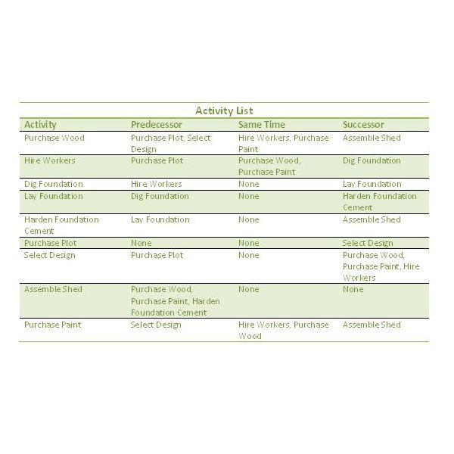

The activity list would contain the entire scope. Generally, the scope of work that needs to be completed is broken into more manageable phases (releases and iterations). Each phase will have its own Precedence Diagram (Project Network Diagram). Prioritizing scope that provides maximum value is important.

**Arrange Project Activities in Order of Execution to create a Precedence Diagram**

After creating the table, you can then proceed to constructing the Precedence Diagram (Project Network Diagram). An example precedence diagram is shown in the image. Refer to the table, while creating the project network diagram. The visual representation helps you to identify missing activities. In this example, “Cut Wood" may be a missing activity, that’ll depend on “Hire Workers." Can you spot any other missing activities?

Usually, there are multiple paths of completion for any project, hence the Precedence Diagram may vary. For example, in the example shown in the image, we could make Purchase Paint dependent on Purchasing Wood. This would alter the precedence diagram and consequently the project schedule.

**Important**: You need to also be aware of Leads and Lags between activities.

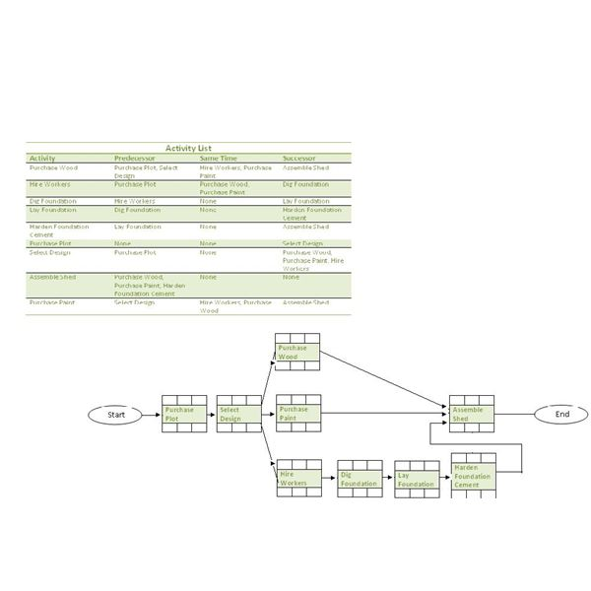

**Tools Used to Create a Precedence Diagram**

In a complex project, you will probably not create the Precedence Diagram (Project Network Diagram) manually as we have done in this example. You will most likely use software, such as PS8, to create the Precedence Diagram. However, even in the software, you will need to manually enter the project activities list and the dependencies between them. The software you use, such as **PS8 or**[**Microsoft Project**](https://www.brighthubpm.com/software-reviews-tips/2516-managing-projects-with-microsoft-office-project-2007-part-one/), will consist of a gamut of other useful features, like **automatically creating the critical path and a**[**Gantt chart**](https://www.brighthubpm.com/project-planning/6550-what-is-a-gantt-chart/).

Another approach to creating a Project Network Diagram used often in teams involves **writing project activities on stickies and then sticking them on a whiteboard**. You will then manually draw the relationship between the project activities. The **advantages of using this approach** are:

* The Project Network Diagram can be created with inputs from several people at the same time.
* High visibility thanks to the whiteboards.
* Quick modification because stickies can be placed anywhere and arrows can be erased easily.

After creating a Network Diagram, you will need to use the Critical Path Method (CPM) to determine:

* the critical path diagram (project activities that can cause delay),
* the Float for each activity
* the optimal project activity flow, and
* Create a schedule.

How to Apply Leads and Lags in Project Management

**Gaining an Understanding**

Precedence Diagrams help you to determine the project activity flow. Through the project activity flow, you can identify the critical path and [compute the float of each activity](https://www.brighthubpm.com/project-planning/49583-calculate-the-float-by-using-the-critical-path-method-cpm/). The schedule is created by using the Precedence Diagram and understanding the relationship between activities. I don’t mean the type of dependencies, such as Finish-to-Start, rather I mean the relationship between two dependent activities. The concept of Lead and Lag is critical in defining this relationship.

Regardless of the type of planning methodology or technique, such as [Agile](https://www.brighthubpm.com/agile/37999-the-30-day-agile-sprint-cycle/)or [Rolling Wave](https://www.brighthubpm.com/project-planning/48953-basics-of-rolling-wave-planning/), the concept of Leads and Lags is applicable.

**Lead**

*Lead* refers to a relationship whereby the successor activity begins before the predecessor activity has completed. For example, suppose you are baking a cake. As part of this, you will need to get the mixture ready and insert the dish into the oven. “Get the Mixture Ready" is the predecessor of “Insert the Dish into the Oven." Pre-heat the oven is a task that is a part of the “Insert the Dish into the Oven" activity. Therefore, the “Insert the Dish into the Oven" activity should start before you’ve completed the “Get the Mixture Ready" activity. Assuming the pre-heating takes 20 minutes, then the “Insert the Dish into the Oven" activity should start 20 minutes before you have completed the “Get the Mixture Ready" activity. Therefore, the “Insert the Dish into the Oven" activity has Lead of 20 minutes.

**Lag**

*Lag* refers to a relationship whereby the successor activity cannot start right after the end of its predecessor. For example, after you’ve baked the cake, you might want to serve it cold. Therefore, before serving it to the guests you will need to put the cake into a fridge and wait for it to cool. This means that the activity “Serve Guests Cake" will not start right after its predecessor “Insert the Dish into the Oven." There is a delay. This delay is called Lag.

Here’s another example. Take a look at the following Precedence Diagram and identify the activity that’ll most probably have a Lag. (Click image for a larger view.)

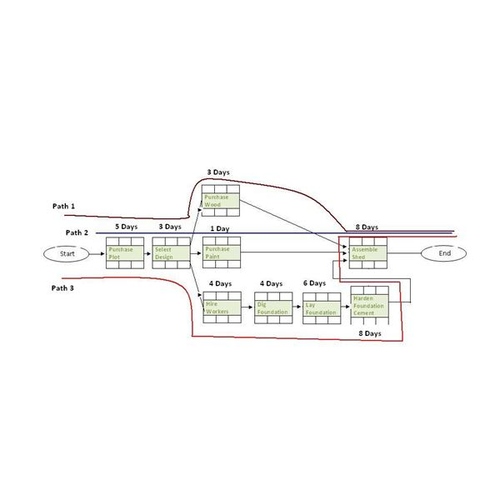

If you identified the "Harden Foundation Cement" activity, then you are correct! Well done. There is a lag between "Lay Foundation" and "Harden Foundation Cement" because the latter activity would only start after the cement has matured. Only then can the construction workers start the "Harden Foundation Cement" activity.

Ensure you understand Leads and Lags before creating a schedule and for [your PMP preparation](https://www.brighthubpm.com/certification/49768-how-i-passed-the-pmp-exam/).

Resource Loading Vs.. Resource Leveling: What’s the Difference?

**Resource Loading**

[Resource loading](https://www.iaresearch.com/jcvganttpro/manual/ResourceLoading.html) mainly involves your manpower or employees. In resource loading, each employee is assigned a task or a percentage of a project (X percent of the whole). Usually, it's 25 percent of the whole. Then the employee is assigned other tasks until he or she reaches 100 percent booked. This would then mean that the employees cannot take on any additional work.

With resource loading, a project manager can predict an employee's hours for the year and see how tasks can be assigned. This also allows the project manager to decide whether or not additional employees or contractors are needed to complete the scheduled projects.

The downside to resource loading is that employees cannot be 100 percent booked. Other things may arise to take away their time, such as unexpected problems that need to be fixed. An employee should always be under 100 percent booked. Resource loading increases the chance that a project will not be completed on time because employees are overloaded with projects.

**Resource Leveling**

While resource loading mainly deals with manpower, resource leveling deals with both time (project starting and ending date) and resources, including manpower and budget. Resource leveling tries to balance the conflicting interests of projects with the available resources.

Resource leveling generally breaks things down into two categories: time and available resources. Some projects need to be finished within a certain time frame. These projects will use all the available resources (money and manpower) to complete the project by a certain date. For a complete overview of resource leveling, read my article "[What is Resource Leveling?](https://www.brighthubpm.com/resource-management/14644-what-is-resource-leveling/)"

Projects that aren't as pressing can be spread out for an indefinite period of time until resources do become available. These projects are usually ones that are not on the critical path and will not affect the project completion date.

Like resource loading, resource leveling also has its problems. It is hard to determine in the beginning which tasks will be on the critical path. Also, delaying a task could cause the entire project to fall behind schedule.